Working with communities
A Relational Approach to

Strategic & Economic Policy
Dr Deborah Ralls
Lecturer in Education
Newcastle University
Cartoon taken from O’Leary et al, 2011, p.17

Introduction
More Inclusive Economies: The need for a Relational Approach
Across the globe, cities are increasingly looking for new ways of addressing issues of inequality and urban poverty by setting out to build more inclusive economies.
These approaches look beyond individualistic, market driven approaches serving private concerns.
A fundamental aspect of more inclusive economic approaches is the belief that a change in relationships based on solidarity and cooperation is essential in developing sustainable and inclusive economies, cities and city regions.
This suggests that, if we are to move towards more inclusive economic approaches, we also need to rethink our approaches to community engagement, starting by considering what type of relationships between communities and policymakers can best future proof inclusive places and economies.
A relational approach to engagement can help. Rather than beginning with an intervention, a relational approach starts by developing a different power dynamic in working with communities to develop strategic engagement policy and practice.

The founding principle of this approach is that:
relationships matter...engagement, then, should be about creating the relationships that provide a foundation for long-term and sustainable change (Warren, 2009, p.2248).

Relational Theory
1: Relational Goods
Relational theory focuses on how relationships can be established to generate the ‘relational goods’ (such as interpersonal trust, emotional support, care and social influence) (Cordelli, 2015) that are required if there is to be a fundamental shift to a more reciprocal relationship between the state, civil society and citizens (Mulgan, 2012).

Interpersonal trust – Cordelli refers to relational trust as ﻿playing an essential role in protecting what people care about in their everyday life, as we cannot possibly take care of everything, at every hour of the day, by ourselves. When we think about strategic and economic policy engagement, as a community we need to trust others and have a sense of security that those we have trusted will help us to achieve what we want to achieve.

Emotional support and care are produced by and available within face-to-face, ongoing relationships, but can also be generated in relationships among and between different stakeholders. In communities experiencing times of challenge, upheaval and change, it is particularly important to acknowledge that emotional support is a core human need, on par with the need for food and sanitation, and necessary to maintain a basic level of physical and mental health.

Social influence is about being able to enhance the strength of one’s claims or the socially perceived worth of one’s own projects, by building relationships that can bring others to share and support those claims and projects. A more relational approach should understand the importance of a reciprocal approach, with a focus on how community members can develop social influence, rather than focusing only on the influence that policymakers and professionals have over the community.

Audit 1: Generating Relational Goods
The audit activities in this Toolkit provide a way of identifying more-or-less relational approaches to engagement in practice and of thinking differently about how we approach community engagement activities for more inclusive strategic and economic policymaking.
The audit activities help us to try and understand the catalysts for more-or-less-relational approaches to engagement. The data gathered can then be used to analyse current approaches, for example mapping out relational approaches geographically and comparing with existing data such as socio-economic indicators.

Activity 1:
- In your work team, decide on 3-4 community engagement activities to consider.
- Work separately to complete a proforma for each engagement activity before considering the questions.
- Come back together as a team to compare and discuss any emerging patterns or themes.
- Think about reciprocity when considering the relational goods, for example how it was evident that the policymakers trusted community members and vice versa?

Note down any patterns and consider:
- Do certain project locations or the engagement of certain stakeholders appear to influence the relational goods that are generated? Why might this be so?
- Does the funding or duration of the project have any impact on the development of relational goods? In what ways?
- Has the generation of relational goods (or the lack of them) affected project outcomes?

Audit 1:

Generating relational goods
Activity | Location | Funding/Duration | Key Stakeholders | Outcomes
Evidence of the generation of interpersonal trust: |  |  | Areas for development:
Evidence of the generation of emotional support & care: |  |  | Areas for development:
Evidence of the generation of social influence: |  |  | Areas for development:

Relational Theory
2: Unilateral or Relational Engagement?

What do we mean by ‘engagement’?
Inclusive economic policy and practice sees ‘engagement’ as important and thinks of it in relation to communities.
However, ‘engagement’ can be understood in many different ways…
  - In the absence of a clear conceptualisation, there is a tendency for professionals to see it as ‘doing to’ stakeholders who are characterised by deficits, rather than ‘doing with’ full partners in the educational process who have all sorts of assets to bring to bear on a joint endeavour (Ferlazzo, 2011).
  - Positioning strategic and economic policy development as a common interest requires a more relational approach, where “partnership underscores mutual interdependence and helps create an understanding of community - not as those with problems, but as the group to which we all belong” (Battistoni, 1997, p. 155).
  - Relational engagement activities need spaces in which to develop relationships that promote the sharing of knowledge based on a common interest that challenges deficit views of certain communities as ‘impoverished’.
  - This also requires a shift in the role of the professional, moving from initiating a one-way intervention to a relational model of engagement where stakeholders are also viewed as resources for professionals’ own learning (Midwinter, 1973, 1975; Benn and Chitty, 1996; Melaville et al, 2006; Warren et al, 2009; O’Leary et al, 2011; Thomas, 2012; Dyson and Kerr, 2013).
The acknowledgement of what professionals need to learn from stakeholders establishes a clear link between a relational and an asset-based approach to engagement. As Foot (2012) explains:
asset approaches make visible, value and utilise the skills, knowledge, connections and potential in a community (p.8).

A unilateral approach to engagement emphasises “‘power over’ others, the capacity to get others to do one’s bidding” (Warren et al, 2009, p.2213), whereas a relational approach, in contrast, is defined as an organisation and its stakeholders getting things done collectively, starting from the point of their “shared interest” (Warren et al, 2009).

A relational approach to engagement is about creating the relationships that can provide a foundation for long-term and sustainable change, not a quick fix (Warren, 2009).

Both local communities and policymakers and professionals have a shared interest in developing a more socially just economy that will also support the wellbeing of community members.

Audit 2: Doing To or Doing With:
What counts as ‘Engagement’?
Current strategic and economic policymaking activities can be evaluated to assess whether they are more ‘unilateral’ or ‘relational’ in their approach to community engagement.
Using the ideas of ‘unilateral’ or ‘relational’ engagement, think about ‘what counts as engagement’ in your current community engagement activities. Use resources like policy documentation, recruitment and marketing information, media accounts and community feedback to identify unilateral and relational approaches, together with examples of community needs and assets.

Activity 2:
- In your work team, decide on 3-4 community engagement activities to consider.
- Work separately to complete a proforma for each engagement activity before considering the questions.
- Come back together as a team to compare and discuss any emerging patterns or themes.

Note down any patterns and consider:
- Do certain project locations or the engagement of certain stakeholders appear to influence the type of engagement activity?
- Why might this be so?
- Does the funding or duration of the project have any impact on the type of activity?
- In what ways?
- Has the type of engagement adopted affected project outcomes?

Audit 2:

Doing to or doing with: what counts as engagement?
Activity | Location | Funding/Duration | Key Stakeholders | Outcomes
Evidence of professional interest or shared interest? |  |  | Areas for development:
Evidence of community areas of need identified: |  |  | Areas for development:
Evidence of community assets identified (tangible): |  |  | Areas for development:
Evidence of community assets identified (intangible): |  |  | Areas for development:

Relational Theory
3: The importance of Bonding & Bridging, Leadership, Culture & Power
Social capital theory informs relational thinking on how to develop a different approach to engagement.
Putnam (2000) suggests that the formation of relationships can result in two different types of social capital: ‘bonding’ or ‘bridging’. Putnam explains that ‘bonding’ capital is exclusive and ‘bridging’ capital is inclusive.
When describing bonding and bridging social capital, Putnam (2000) links these concepts with de Souza Briggs’ (1998) distinction between social capital that results in social support and helps one to ‘get by’ (bonding) and social capital that results in social leverage, helping one to ‘get ahead’ (bridging). So, setting out to develop relationships based on bonding social capital can help to build relationships required for collaboration, whereas developing relationships based on bridging social capital can help to address issues of gaps in culture and power.
The need for both bonding and bridging social capital underpins Warren et al’s (2009) 3 core elements of relational engagement.

Elements of Relational Engagement (adapted from Warren et al, 2009, p. 2210)

An emphasis on relationship building among a particular group of stakeholders (e.g. community members) and between community members and policymakers/politicians (officers/members).

A focus on the leadership development of stakeholders.

An effort to bridge the gap in culture and power between stakeholders and policymakers and politicians.

Audit 3:
Warren et al’s (2009) 3 core elements of relational engagement

Activity 3:
  - In your work team, decide on 3-4 community engagement activities to consider.
  - Work separately to complete a proforma for each engagement activity before considering the questions.
  - Come back together as a team to compare and discuss any emerging patterns or themes.

Note down any patterns and consider:
- Do certain project locations or the engagement of certain stakeholders appear to influence the development of bonding/bridging relationships, leadership opportunities for community members or opportunities to bridge gaps in culture and power?
- Why might this be so?
- Does the funding or duration of the project have any impact?
- In what ways?
- What were the outcomes of the project – from a community perspective? From a professional perspective?
- How might different approaches to the development of bonding/bridging relationships, leadership opportunities for community members or opportunities to bridge gaps in culture and power impact on future project outcomes?

Audit 3:

Social Capital & 3 Core Elements of Relational Engagement
Activity | Location | Funding/Duration | Key Stakeholders | Outcomes
Evidence of an explicit aim to build relationships among community members? |  |  | Areas for development:
Evidence of an explicit aim to build relationships between policymakers, local politicians, other professionals and community members? |  |  | Areas for development:
Evidence of leadership development activities: |  |  | Areas for development:
Evidence of efforts to bridge gaps in culture and power: |  |  | Areas for development:

Bringing it all together:
Considering the relational potential of engagement activities
Having considered different aspects of relational engagement, decisions can start to be made about the relational potential of different types of activities and how aspects such as location and funding may impact on this potential.
The final audit invites teams to make a judgement regarding the relational potential of different areas of engagement activity.
These judgements are made based on the initial data gathered in the engagement audits and are meant as a starting point for exploring in detail how the relational potential of these activities plays out in practice and the impact that this has on inclusive approaches to strategic and economic development.

Auditing the Relational Potential of Engagement Activities
Activity | Who | Where | Relational Goods | Shared Interest | Community assets | Relationship building among the community | Relationship building between the community & professionals | Leadership development | Bridging gaps in culture and power

The Ladder of Engagement
Cross Checking Professional Understandings
Once the engagement audits have been conducted, it is essential to keep cross checking professional perceptions of community engagement with community members themselves, to understand whether they share the same perspectives on engagement.
In this way project planning can start to take into account any similarities between professional and community understandings, acknowledge and discuss contrasts in preferred engagement approaches or understandings that emerge, and to find opportunities to query why such similarities and differences may be occurring.

Using the Ladder of Engagement is a helpful tool in beginning this process.
  - The activity counteracts a criticism that it remains the professionals themselves who discuss the ladder of participation and debate where work needs to be done on the ladder (Bovaird and Loeffler, 2012).
  - After professionals have carried out this activity, stakeholders are asked to place their different engagement experiences on an ‘engagement ladder’.
  - The activity is designed so that the participants themselves can discuss and interact with the ladder – and make suggestions for change.
  - The activity generates a range of professional and community member responses, with all the associated shared insights and perspectives that this involves and starts the thinking process about what changes in strategy and practice could support more relational approaches.
  - The Ladder of Engagement activity explicitly acknowledges the importance of professionals learning from stakeholders, so as to gain a better understanding of the experiences, culture and assets of communities, as well as resources that communities may lack (Warren et al, 2009).

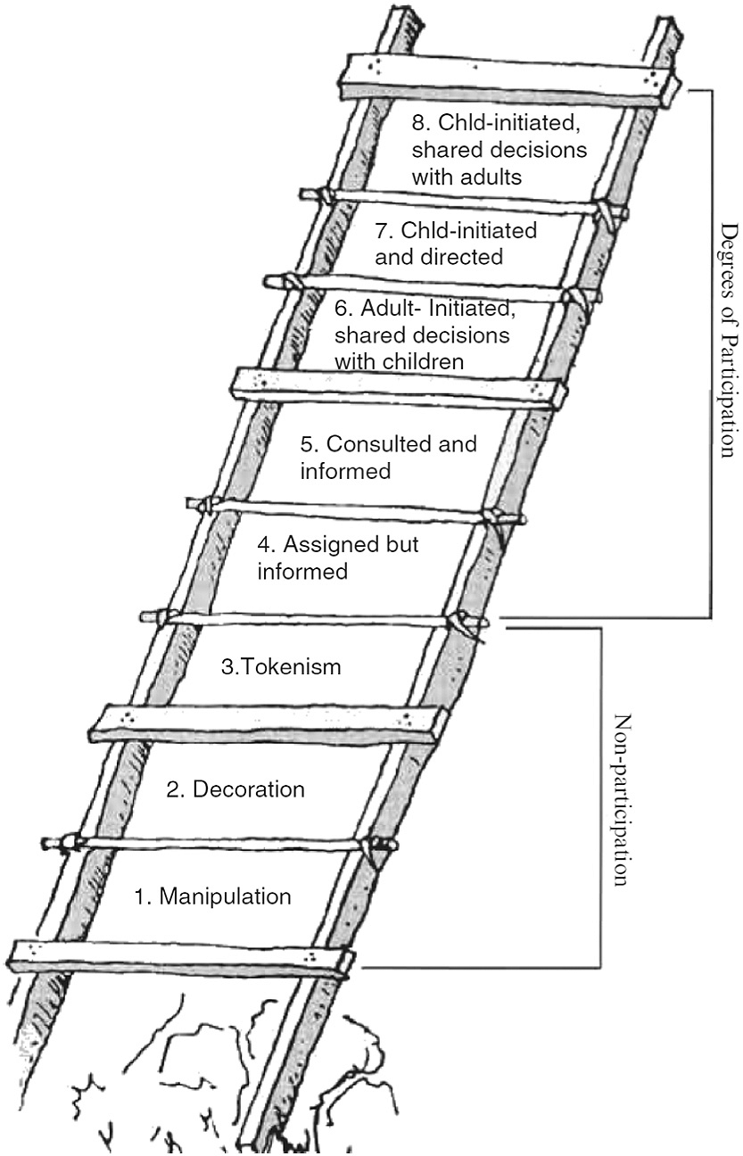

The Ladder of Engagement is adapted from Hart’s (1992) Ladder of Participation.

In his essay for UNICEF, Children’s Participation: From Tokenism to Citizenship, Hart (1992) adapted Arnstein’s Ladder of Citizen Participation (1969, p.217) “to serve as a beginning typology for thinking about children’s participation in projects” (p.9).

Activity 4
After conducting an engagement audit, the team invites community members to discuss their experiences of the project process.
This can be done in different ways:
In a community space, The Ladder of Engagement can be displayed in a large paper format. Participants can work in small groups to consider their opinions on where different engagement activities (and the different stages of those activities) lie on the Ladder. Post its can be used to write individual comments and reflections, to identify where the project activity/stage of activity appears on the ladder and to discuss the key components that participants think would move future activities towards ‘doing with’ rather than ‘doing to’.
Participants can be asked which policymakers/professionals they would like to work with/get to know, and who the key people are in their community that professionals need to work with/get to know. Participants should have the opportunity to say what information they need from professionals/policymakers and what skills and knowledge they need to develop – and vice versa.
In order to cross-reference thoroughly, questions can be tailored to focus on information from the 3 audits (e.g. asking participants about relational goods such as trust, social influence, emotional support, awareness of community assets etc).
The activity could also be conducted online using a tool such as Padlet etc, with different activities under different tabs.
The activity enables an ongoing comparison of professional and community perceptions and understandings of engagement, and how to move towards a shared understanding of a relational model.

Ladder of Engagement
Equal partners  Stakeholders and the organisation (e.g. the city council) share the decision-making. Stakeholders have the ideas, set up the project and invite the organisation to join in the decision-making. | Doing With  Doing To
Shared decisions
The organisation has the main idea, stakeholders help make decisions, plan and carry out the project.
Consulted
Stakeholders are consulted and informed.

The organisation designs and develops the project but stakeholders’ opinions are taken into account and feedback given.
Assigned
Stakeholders are assigned but informed.
The organisation decides on the project and stakeholders volunteer. Stakeholders understand the project and the organisation respects their views.
Tokenism
Stakeholders have limited voice & choice about what they can say and how they can communicate.
Decoration
Stakeholders take part in an event in a very limited way and have no role in decision-making.
Manipulation
The organisation has complete and unchallenged authority and they use stakeholders’ ideas and choices for their own gain.
Adapted from Hart’s Ladder of Participation (1992)

